Jenkins Database Backup Job

Steps to complete this task:

1. Login to Jenkins
- Open the Jenkins UI.
- Enter the username and password.
- Click Sign in.
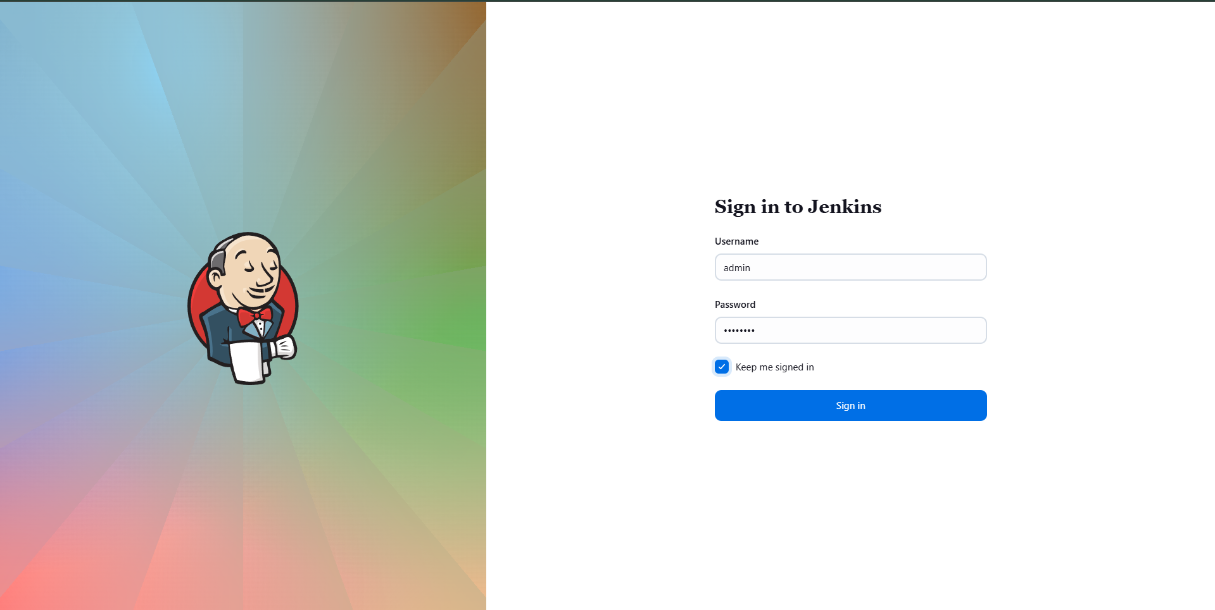

2. Install Required Plugin
- Go to Manage Jenkins → Plugins → Available plugins.
- Search for SSH.
- Select:
  - SSH
  - SSH Credentials
- Click Install.
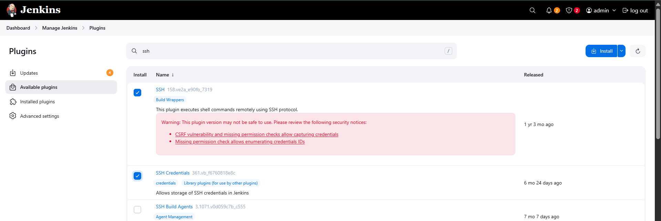
- Restart Jenkins using Safe Restart after installation.


3. Configure Credentials for Database Server

3.1 Create Domain for DB
- Navigate to Manage Jenkins → Credentials → System → Add domain.
- Enter domain name: db.
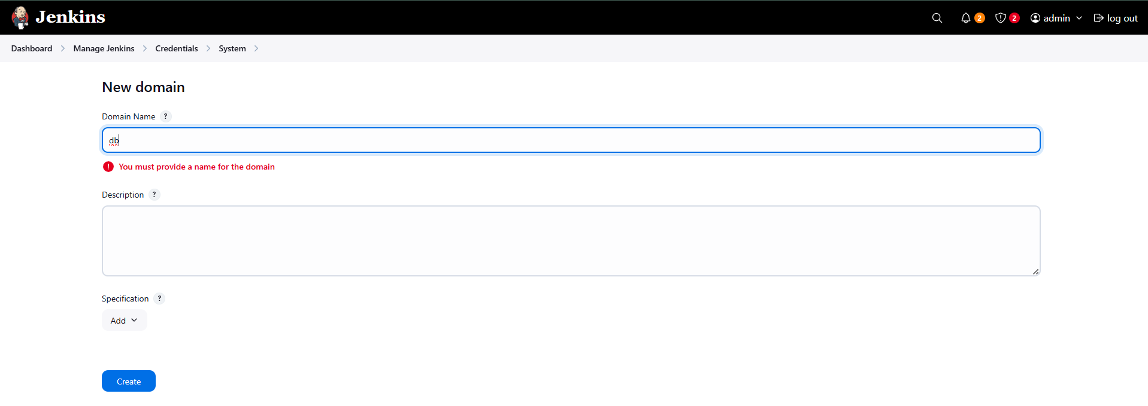
- Click Create.

3.2 Add DB Credentials
- Open the newly created db domain.
- Click Add Credentials.
- Select Kind → Username with password.
- Enter:
  - Username: peter
  - Password: <db server password>
  - ID: db-usr
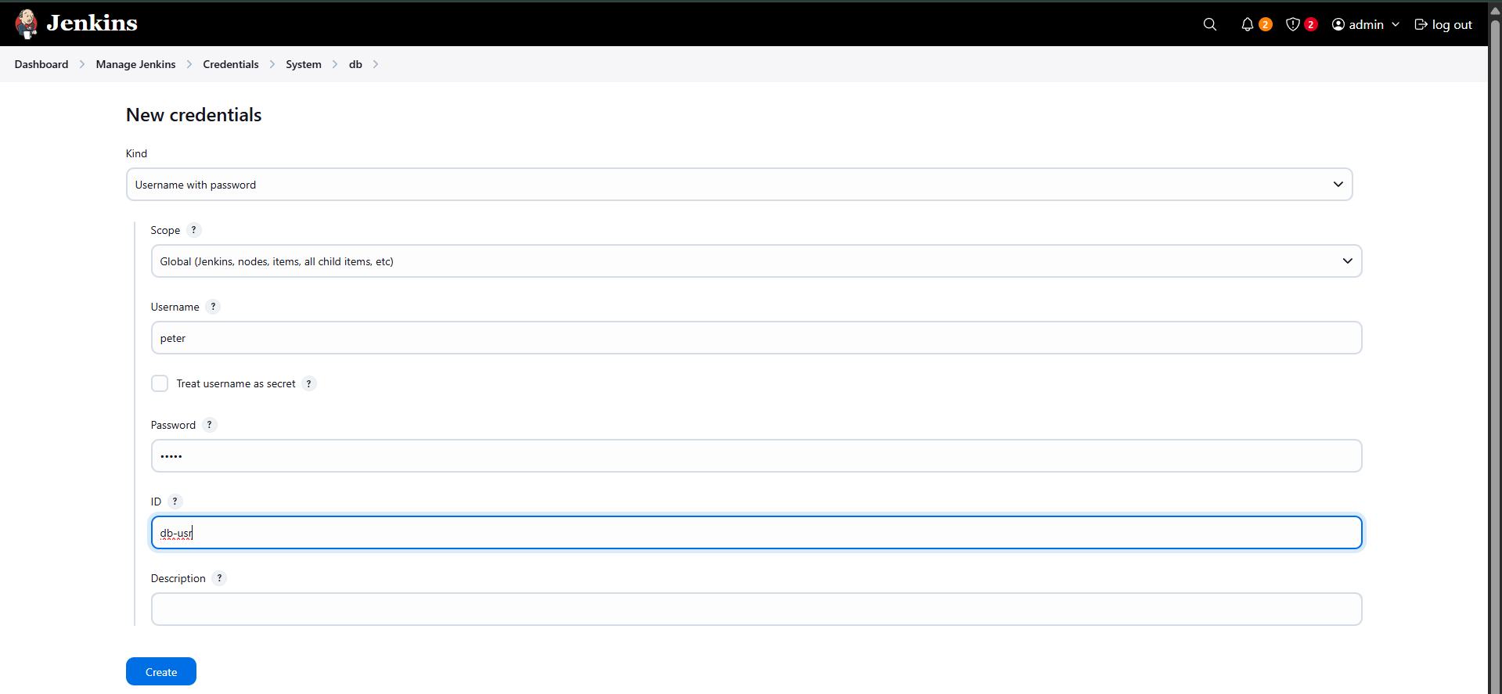
- Click Create.

4. Configure Credentials for Backup Server

4.1 Create Domain for Backup
- Go to Manage Jenkins → Credentials → System → Add domain.
- Enter domain name: bkp.
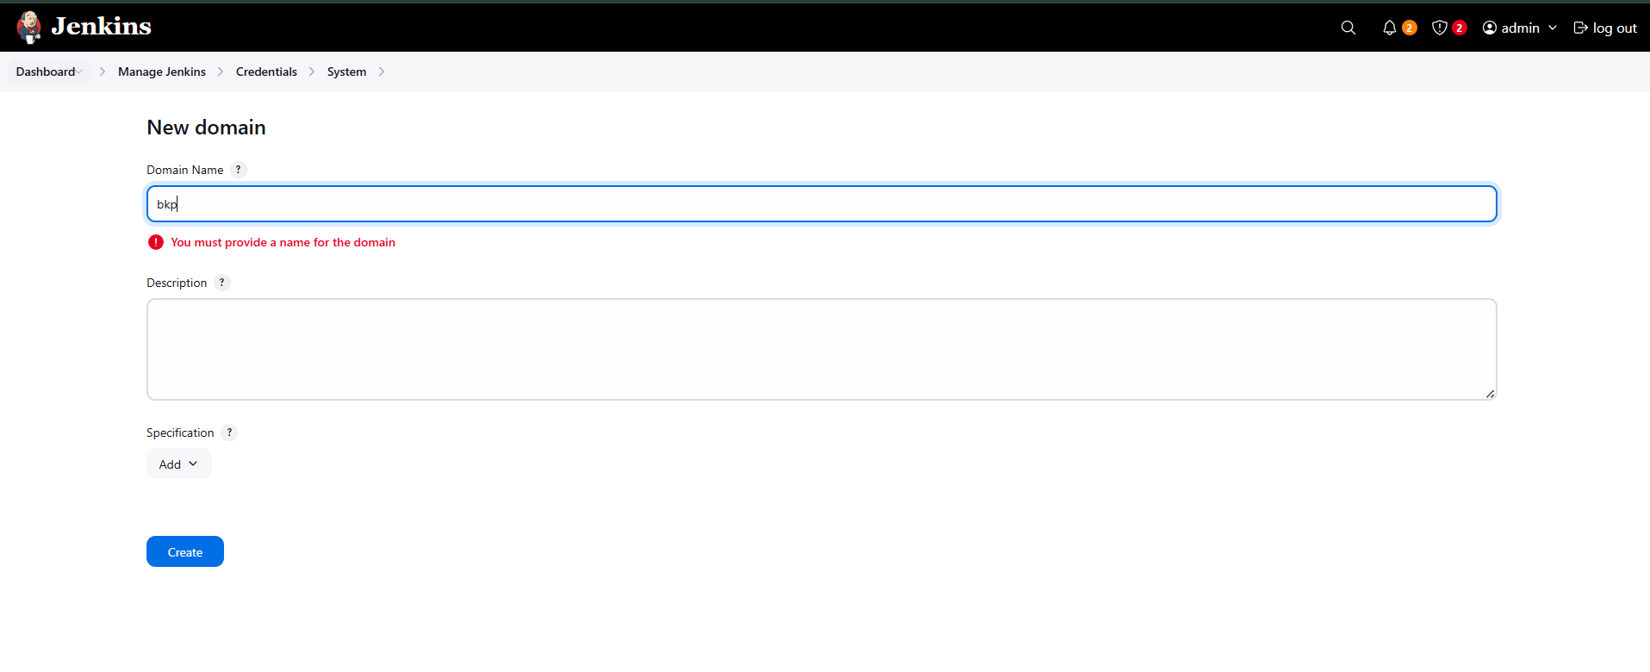
- Click Create.

4.2 Add Backup Server Credentials
- Open bkp domain.
- Click Add Credentials.
- Select Kind → Username with password.
- Enter:
  - Username: clint
  - Password: <backup server password>
  - ID: bkp-usr
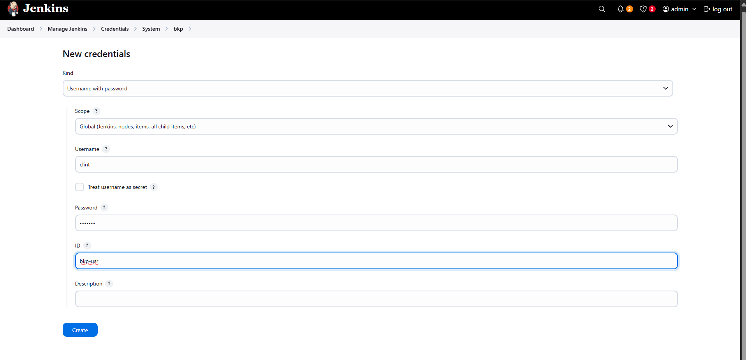
- Click Create.

5. Configure SSH Remote Host (Database Server)
- Go to Manage Jenkins → System.
- Locate SSH remote hosts section.
- Add new SSH site with:
  - Hostname: stdb01
  - Port: 22
  - Credentials: peter
- Enable PTY.
- Click Check connection → ensure it shows Successful connection.
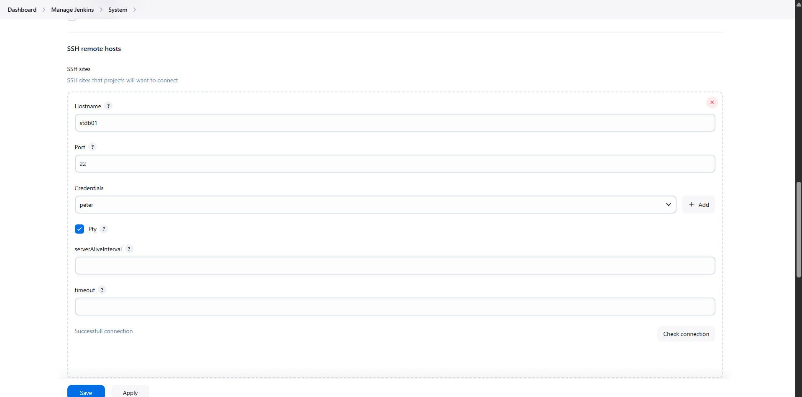
- Click Save.

6. Validate Server Access Manually (Pre-check)

6.1 DB Server
- SSH into DB server:
ssh peter@stdb01
- Switch to root and login to MySQL:
sudo -i
mysql
- Verify database:
show databases;
Confirm kodekloud_db01 exists.
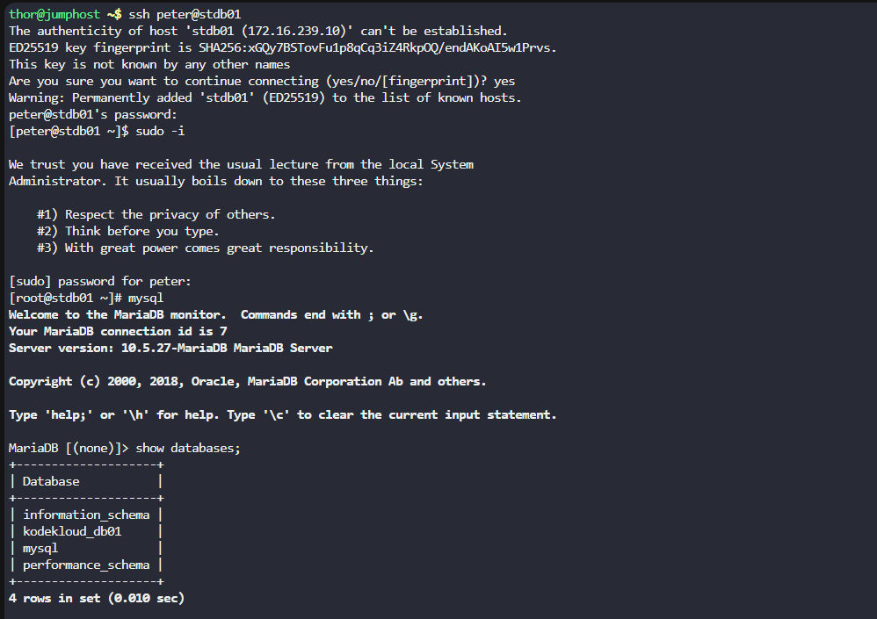

6.2 Backup Server
- SSH into backup server:
ssh clint@stbkp01
- Verify backup directory:
cd db_backups
ls –l
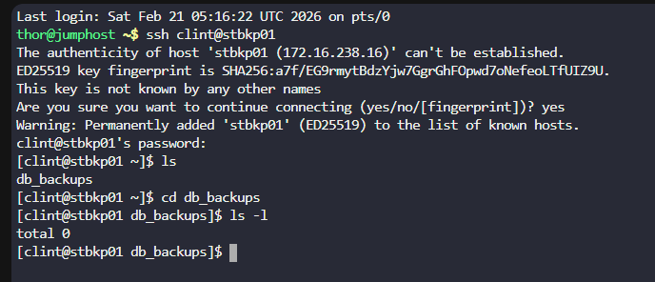

7. Create Jenkins Job
- Click New Item.
- Enter name: database-backup.
- Select Freestyle project.
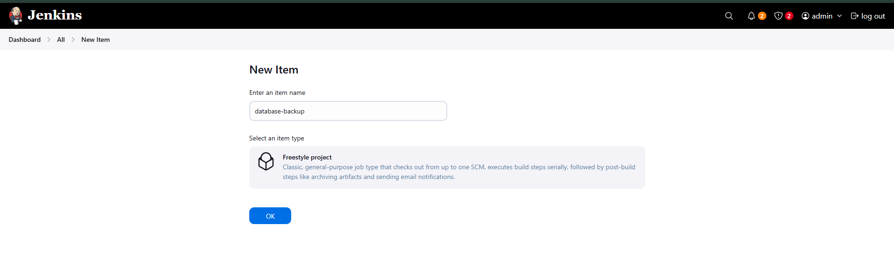
- Click OK.

8. Configure Build Trigger (Scheduling)
- Go to Build periodically.
- Enter cron:
*/10 * * * *
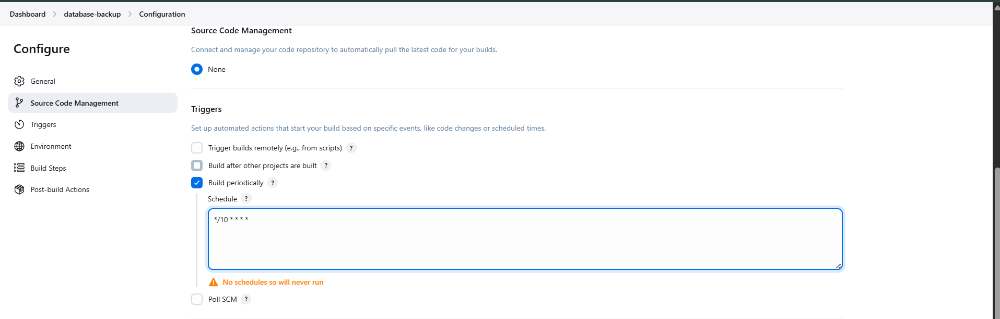

9. Configure Build Step
- Go to Build Steps → Execute shell script on remote host using SSH.
- Select SSH site: peter@stdb01:22.
- Enter command:
mysqldump kodekloud_db01 -u kodekloud_roy -pasdfgdsd > db_$(date +%F).sql
sshpass -p "H@wk3y3" scp -o StrictHostKeyChecking=no db_$(date +%F).sql clint@stbkp01:/home/clint/db_backups
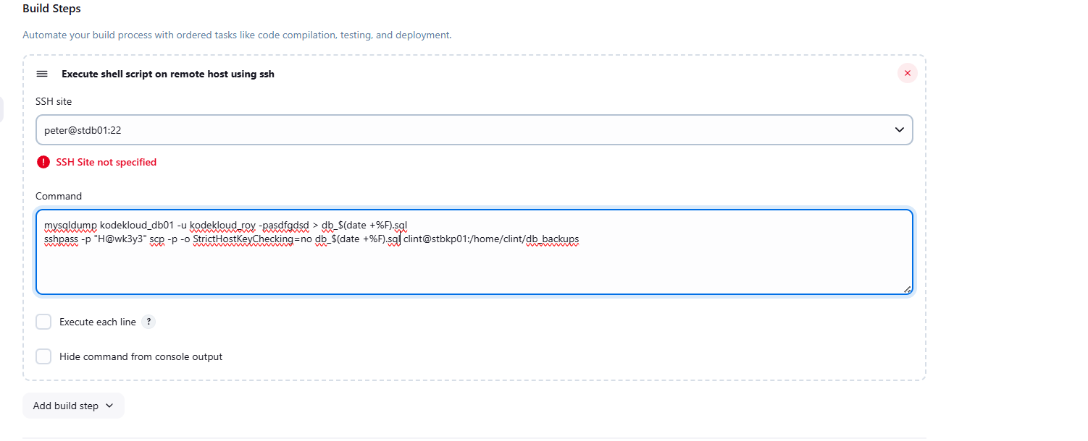

10. Save and Build the Job
- Click Save.
- Click Build Now.

11. Verify Build Output
- Open Console Output.
- Confirm:
  - SSH execution completed
  - Finished: SUCCESS
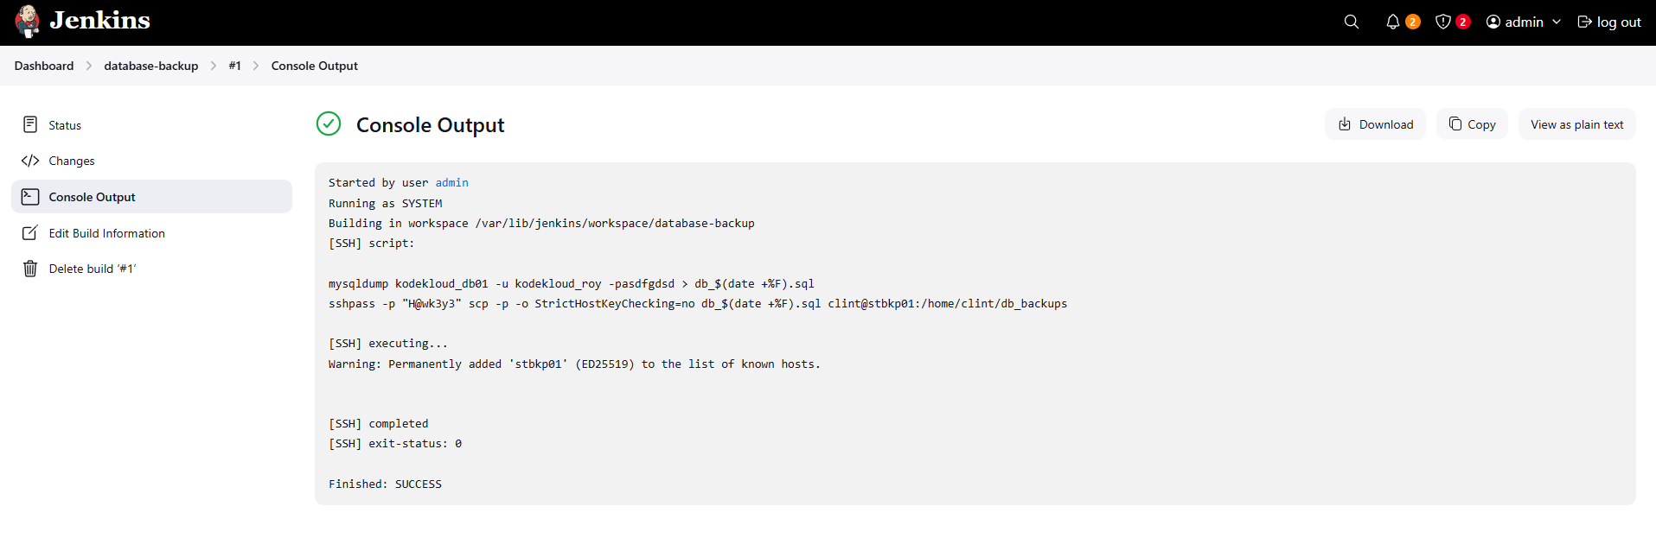

12. Validate Backup on Backup Server
- SSH into backup server:
ssh clint@stbkp01
- Check backup directory:
cd db_backups
ls -l
- Confirm file:
db_YYYY-MM-DD.sql
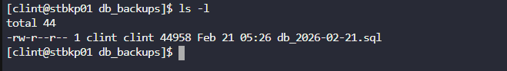

Result
- Jenkins job runs every 10 minutes.
- Database dump is created on DB server.
- Backup is copied to /home/clint/db_backups on backup server.
- Build status shows SUCCESS.

